Appositive

🔹 What is Appositive
# Source: AI Source: Provided by: [Data Path: Persons Table -> ID Column: 1, Name_En Column: Motasem Essam] -> From: [Chatgpt (GPT-4-turbo)] on [8/3/2025]
An appositive is a noun, noun phrase, or noun clause that sits next to another noun to rename, identify, or further explain it.
The appositive function is to provide more information about a noun or pronoun.
🧠 It performs a noun-like function and often appears between commas (especially if nonessential).

✅ Key Characteristics:
# Source: AI Source: Provided by: [Data Path: Persons Table -> ID Column: 1, Name_En Column: Motasem Essam] -> From: [Chatgpt (GPT-4-turbo)] on [8/3/2025]
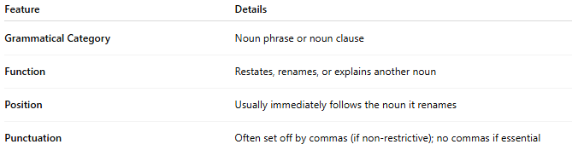
Feature | Details
Grammatical Category | Noun phrase or noun clause
Function | Restates, renames, or explains another noun
Position | Usually immediately follows the noun it renames
Punctuation | Often set off by commas (if non-restrictive); no commas if essential

✅ Examples of Appositives in Sentences:
# Source: AI Source: Provided by: [Data Path: Persons Table -> ID Column: 1, Name_En Column: Motasem Essam] -> From: [Chatgpt (GPT-4-turbo)] on [8/3/2025]
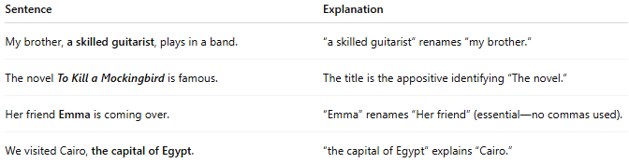
Sentence | Explanation
My brother, a skilled guitarist, plays in a band. | “a skilled guitarist” renames “my brother.”
The novel To Kill a Mockingbird is famous. | The title is the appositive identifying “The novel.”
Her friend Emma is coming over. | “Emma” renames “Her friend” (essential—no commas used).
We visited Cairo, the capital of Egypt. | “the capital of Egypt” explains “Cairo.”

✅ Types of Appositives:
# Source: AI Source: Provided by: [Data Path: Persons Table -> ID Column: 1, Name_En Column: Motasem Essam] -> From: [Chatgpt (GPT-4-turbo)] on [8/3/2025]
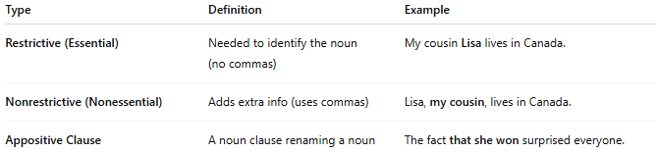
Type | Definition | Example
Restrictive (Essential) | Needed to identify the noun (no commas) | My cousin Lisa lives in Canada.
Nonrestrictive (Nonessential) | Adds extra info (uses commas) | Lisa, my cousin, lives in Canada.
Appositive Clause | A noun clause renaming a noun | The fact that she won surprised everyone.

✅ Functions of Appositives:
# Source: AI Source: Provided by: [Data Path: Persons Table -> ID Column: 1, Name_En Column: Motasem Essam] -> From: [Chatgpt (GPT-4-turbo)] on [8/3/2025]
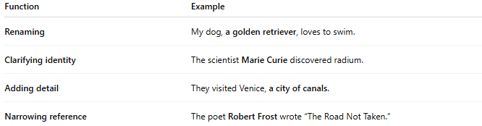
Function | Example
Renaming | My dog, a golden retriever, loves to swim.
Clarifying identity | The scientist Marie Curie discovered radium.
Adding detail | They visited Venice, a city of canals.
Narrowing reference | The poet Robert Frost wrote “The Road Not Taken.”

✅ Appositive vs Modifier:
# Source: AI Source: Provided by: [Data Path: Persons Table -> ID Column: 1, Name_En Column: Motasem Essam] -> From: [Chatgpt (GPT-4-turbo)] on [8/3/2025]
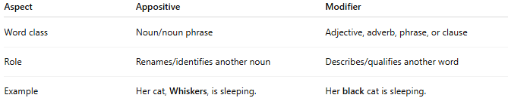
Aspect | Appositive | Modifier
Word class | Noun/noun phrase | Adjective, adverb, phrase, or clause
Role | Renames/identifies another noun | Describes/qualifies another word
Example | Her cat, Whiskers, is sleeping. | Her black cat is sleeping.

✅ Appositive vs Complement:
# Source: AI Source: Provided by: [Data Path: Persons Table -> ID Column: 1, Name_En Column: Motasem Essam] -> From: [Chatgpt (GPT-4-turbo)] on [8/3/2025]
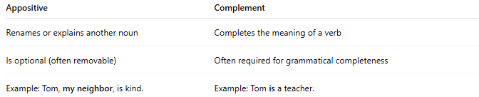
Appositive | Complement
Renames or explains another noun | Completes the meaning of a verb
Is optional (often removable) | Often required for grammatical completeness
Example: Tom, my neighbor, is kind. | Example: Tom is a teacher.

📝 Summary:
# Source: AI Source: Provided by: [Data Path: Persons Table -> ID Column: 1, Name_En Column: Motasem Essam] -> From: [Chatgpt (GPT-4-turbo)] on [8/3/2025]
- Appositives are nouns or noun phrases that rename or define another noun.
- Can be restrictive (essential) or nonrestrictive (extra detail).
- Function as noun modifiers, not to be confused with adjectives or complements.

